The view of civil ANSPs of
the BeNeLux States, Germany,
France and Switzerland (the “7 ANSPs”)
on the
FAB Europe Central strategic ambitions
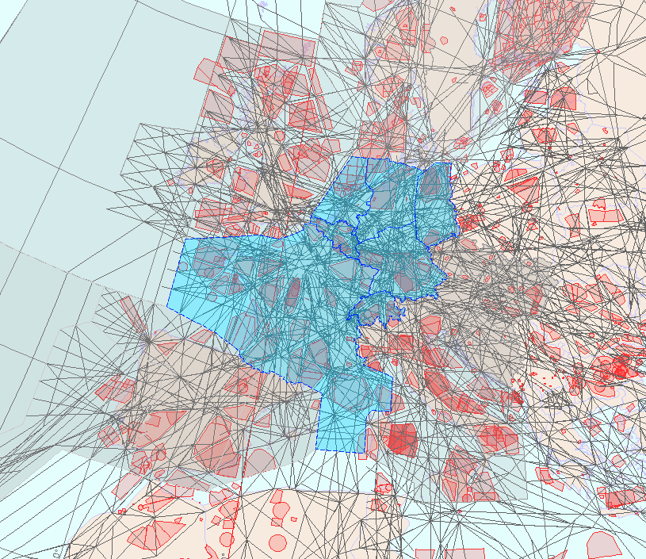

CANCELLED!

DUE TO LACK OF SOCIAL DIALOGUE
and
STAFF REPRESENTATIVES
INVOLVEMENT
!!!!!!!!!!!!!





